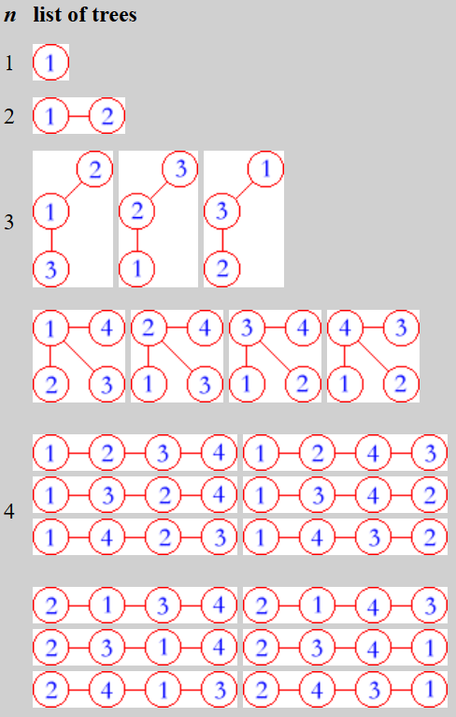How many labeled unrooted trees with n nodes?

labeled means labelling the n nodes with n distinct numbers

Cayley’s formula: there are $n^{n-2}$ labeled unrooted trees

Prufer’s proof:

There are $n^{n-2}$ distinct sequences with length $n-2$, each element being an integer from 1 to n. (also called Prufer codes)

Establish a bijection between the set of sequences and the set of trees.

How to find Prufer code of a tree (Prufer encoding algorithm):

while (more than 1 edge in the tree){

find vertex v with degree 1, choose the one with smallest label

append v’s neighbour to the code

delete v

}

find tree from Prufer code (Pruder decoding algorithm):

P = Prufer code, V = {1 to n}

for (i = 1 to n – 2){

find v, the smallest element in V that is not in P

connect v and p[i]

delete v from V and p[i] from P

connect remaining 2 vertices in V

For each tree there is a prufer code, and for each prufer code theres a tree 🡪 bijection

Important observation: each node appears its degree – 1 times in the Prufer code

Problem: number of ways to make the graph connected

Given an undirected graph with k components, find the number of ways to add k – 1 edges such that the graph becomes connected.

Let $s_{1}, s_{2}, …, s_{k}$ be the sizes of the components.

If we view the k components as vertices, we are basically constructing a tree.

If an edge connect components i and j, it will multiply $s_{i}$ and $s_{j}$ to the answer. (because we need to choose 1 vertex from each component)

big observation: each component contributes $s_{i}^{d_{i}}$ to the answer where $d_{i}$ is the degree

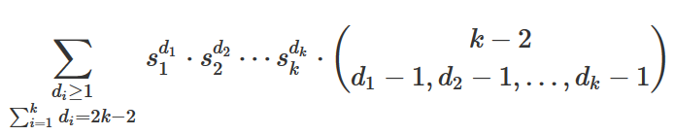

wow

wtf is this

we can use the **multinomial theorem**

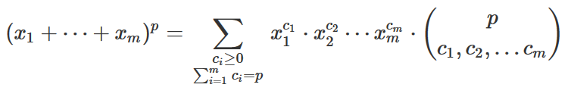

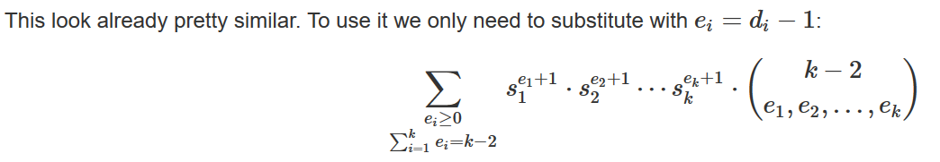

Therefore, it becomes



where $n$ is number of vertices (not components)